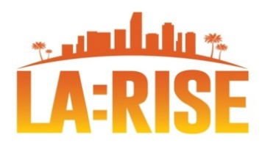
CALJOBSSM Correction Form & TA Request PY 23-24

SELECT PROGRAM: ☐ Regional LA:RISE ☐ LA:RISE Youth Academy CA4A
REQUESTOR INFORMATION
Requested By |  | Phone Number |  | Email Address |  |  | Date
WORKFORCE PARTNER |  | SOCIAL ENTERPRISE PARTNER |  |  |  | OTHER
☐ Boyle Heights WSC (MCS)  ☐ Hollywood WSC (MCS)  ☐ Northeast LA WSC (Goodwill)  ☐ Sun Valley WSC (El Proyecto)  ☐ Sun Valley YSC (El Proyecto)  ☐ Vernon Central LATTC WSC (CRCD)  ☐ West Los Angeles YSC (UCLA YSC)  ☐ Central LA- AYE YSC (Catholic Charities)  ☐ Westlake YSC (Para Los Niños)  ☐ Northeast YSC (Para Los Niños)  ☐ Harbor YSC (MCS) |  | ☐ Anti-Recidivism Coalition  ☐ Center for Employment Opportunities  ☐ Center for Living and Learning  ☐ Chrysalis  ☐ CRCD Enterprises  ☐ Downtown Women’s Center  ☐ Goodwill SE  ☐ GRID Alternatives  ☐ Homeboy Industries  ☐ LA Conservation Corps  ☐ LA LGBT Center |  |  |  | ☐Other:
PARTICIPANT INFORMATION
Participant Name |  |  | State ID
WIOA Application # |  |  | Agency Defined Application #
REASON FOR CORRECTION / TECHNICAL ASSISTANCE REQUEST
SUBMISSION INFORMATION
To: LA City MIS Section, Email: celene.heredia@lacity.org and emoli.mendez@lacity.org.

Email Subject: LA:RISE Correction Request Form – Participant Name
Example: “LA:RISE Correction Request Form – John Doe”

CITY MIS USE ONLY
Mis Analyst Assigned: | Date: |  |  |  | Status  ☐ Approved ☐ Denied
Notes:

